**Jharkhand Urja Sancharan . Nigam Limited**

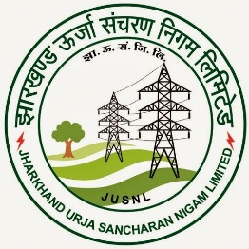

TRANSMISSION SUB-STATION

. HATIA-1(132/33KV) & HATIA-2(220/132KV)

**Submitted in the Month of Under the Guidance of :**

**February 2021 by : Aseem Toppo**

**Name :- Rohit Tirkey**

**Roll No :- 1801073**

**As part of Bachelor of Technology (Electrical Engineering)**

**Curriculum of**

**Birsa Institute of Technology, Sindri, Jharkhand**

**ACKNOWLEDGEMENT**

Presentation inspiration and motivation have always played a key role in the success of any venture. We acquired this opportunity with much pleasure to acknowledge the invaluable assistance of all the people who have helped us through the course of our journey in successful completion of this project.

We would like to express our deepest gratitude to all member of staff ofHatia Grid I & II Substation for their active support and continuous guidance without which it would have been difficult for us to complete this project.

Their guidance helped us to successfully complete the project within given time frame of two weeks (from 28th January 2021 to 12th February 2021).

**INDEX**

1. Introduction…………………………………………………………………………………………4-12
2. Transformers……………………………………………………………………………………….12-24
3. Circuit Breaker…………………………………………………………………………………….25
4. Current Transformer (CT)…………………………………………………………………….26
5. Isolators………………………………………………………………………………………………27
6. Potential (Voltage) Transformer (PT)…………………………………………………..28
7. Capacitive Voltage Transformers (CVT) ………………………………………………29
8. Lightening Arrester (LA)………………………………………………………………………30

9 Wave Trap (WT)…………………………………………………………………………………..31

10 Insulators………………………………………………………………………………………….32-33

11 Relay ……………………………………………………………………………………………….33-34

12 Bus Bar……………………………………………………………………………………………..35

13 Bus Coupler……………………………………………………………………………………….36

14 DC System…………………………….…………………………………………………………..37

15 PLCC…………………………………………………………………………………………………..38

16 Control System………………………………………………………………………………….39

17 Substation & Equipment Earthing………………………………………………………40-45

18 Conclusion…………………………………………………………………………………………46

**1.Introduction**

The project work assign to us was the study of whole design and working of HATIA-1(132/33KV) & HATIA-2(220/132KV) Substation.

Working/Function of GSS Hatia-1

The incoming power is of 132KV which is fed to Bus Bar (132 KV Main Bus) through LA Isolators, Circuit Breaker(CB), Current Transformer(CT) combination.The power from main Bus is fed to different 132KV Outgoing Line and also into 4x50 MVA Power Transformer which is stepped down to Voltage of 33KV and fed to Bus Bar (33KV Main Bus) from which different Loads is tapped to distribution sub-station

Working/Function of GSS Hatia-2

The incoming power is of 220KV which is fed to Bus Bar (220 KV Main Bus) through LA Isolators, Circuit Breaker(CB), Current Transformer(CT) combination.The power from main Bus is fed to different 220KV Outgoing Line and also into 3x150 MVA Power Transformer which is stepped down to Voltage of 132KV and fed to Bus Bar (132KV Main Bus) from which different Loads is tapped to distribution sub-station

***Single line diagram of Grid Hatia 1***

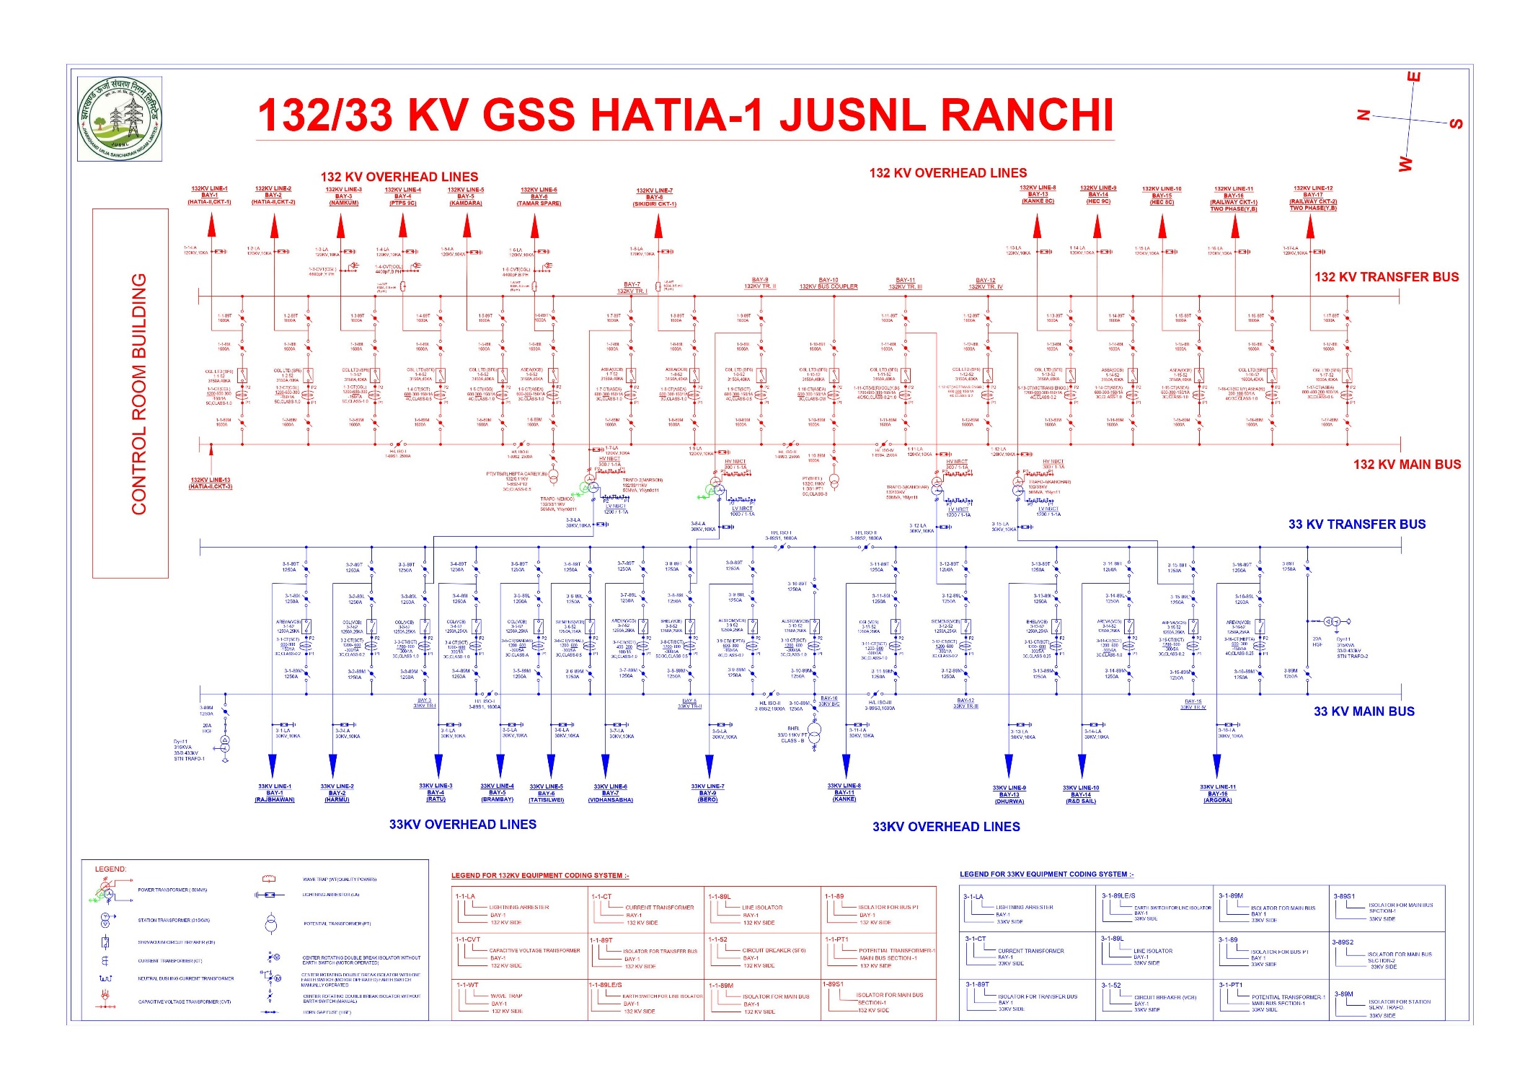

***Single line diagram of Grid Hatia 2***

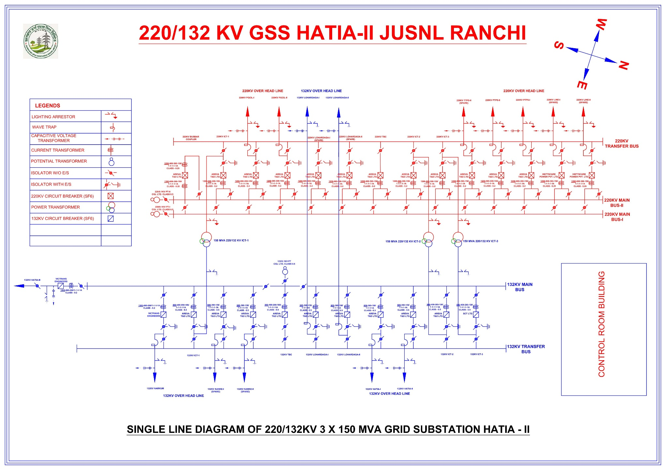

**Power System**

Power System

The power system is a network which consists generation, distribution and transmission system. It uses the form of energy (like coal and diesel) and converts it into electrical energy. The power system includes the devices connected to the system like the [synchronous generator,](https://circuitglobe.com/synchronous-generators.html) motor, [transformer,](https://circuitglobe.com/what-is-a-transformer.html) [circuit breaker](https://circuitglobe.com/circuit-breaker.html), conductor, etc.

The power plant, transformer, transmission line, substations, distribution line, and distribution transformer are the six main components of the power system.The power plant generates the power which is step-up or step-down through the transformer for transmission.

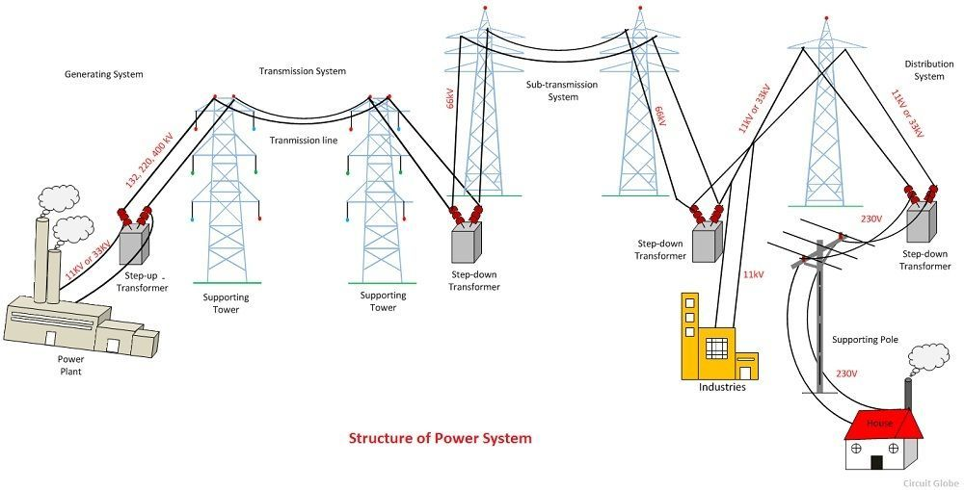

Structure of Power System

The power system is the complex enterprise that may be subdivided into the following sub-systems.The subsystems of the power system are explained below in details.

Generating Substation

In generating station the fuel (coal, water, nuclear energy, etc.) is converted into electrical energy. The electrical power is generated in the range of 11kV to 25kV, which is step-up for long distance transmission. The power plant of the generating substation is mainly classified into three types, i.e., thermal power plant, hydropower plant and nuclear power plant.

The generator and the transformer are the main components of the generating station. The generator converts the mechanical energy into electrical energy. The mechanical energy comes from the burning of coal, gas and nuclear fuel, gas turbines, or occasionally the internal combustion engine.

The transformer transfers the power with very high efficiency from one level to another. The power transfer from the secondary is approximately equal to the primary except for losses in the transformer. The step-up transformer will reduce losses in the line which makes the transmission of power over long distances

Transmission Substation

The transmission substation carries the overhead lines which transfer the generated electrical energy from generation to the distribution substations. It only supplies the large bulk of power to bulk power substations or very big consumers.The transmission lines mainly perform the two functions

1. It transports the energy from generating stations to bulk receiving stations.
2. It interconnects the two or more generating stations.The neighbouring substations are also interconnected through the transmission lines.

The transmission voltage is operating at more than 66kv and is standardised at 69kv, 115KV, 138KV, 161KV, 230KV, 345KV, 500KV, and 765KV, line-to-line. The transmission line above 230KV is usually referred to as extra high voltage (EHV).

Distribution Substation

The component of an electrical power system connecting all the consumers in an area to the bulk power sources is called a distribution system.The bulk power stations are connected to the generating substations by transmission lines. They feed some substations which are usually situated at convenient points near the load centres.

The substations distribute the power to the domestic, commercial and relatively small consumers. The consumers require large blocks of power which are usually supplied at sub-transmission or even transmission system.

About Sub-Station

*“The assembly of apparatus used to change some characteristics (e.g. Voltage ac to dc freq. p.f. etc) of electric supply is called sub-station”*

A substation is a part of an electrical generation, transmission, and distribution system. Substations transform voltage from high to low, or the reverse, or perform any of several other important functions. Between the generating station and consumer, electric power may flow through several substations at different voltage levels. Substations may be owned and operated by an electrical utility, or may be owned by a large industrial or commercial customer. Generally substations are unattended, relying on SCADA for remote supervision and control. A substation may include transformers to change voltage levels between high transmission voltages and lower distribution voltages, or at the interconnection of two different transmission voltages. The word substation comes from the days before the distribution system became a grid. As central generation stations became larger, smaller generating plants were converted to distribution stations, receiving their energy supply from a larger plant instead of using their own generators. The first substations were connected to only one power station, where the generators were housed, and were subsidiaries of that power station.

***Types of Substation:***

Substations may be described by their voltage class, their applications within the power system, the method used to insulate most connections, and by the style and materials of the structures used. These categories are not disjointed; to solve a particular problem, a transmission substation may include significant distribution functions, for example.

• Transmission substation

• Distribution substation

• Collector substation

• Converter substation

• Switching station

***Selection of Site***

Main points to be considered while selecting the site for Grid Sub-Station are as follows:

1. The site chosen should be as near to the load center as possible.
2. It should be easily approachable by road or rail for transportation of equipments.
3. Land should be fairly leveled to minimize development cost.
4. Source of water should be as near to the site as possible. This is because water is required for various construction activities (especially civil works), earthing and for drinking purposes etc.
5. The sub-station site should be as near to the town / city but should be clear of public places, aerodromes, and Military / police installations.
6. The land should be have sufficient ground area to accommodate substation equipments, buildings, staff quarters, space for storage of material, such as store yards and store sheds etc. with roads and space for future expansion.
7. Set back distances from various roads such as National Highways, State Highways should be observed as per the regulations in force.
8. While selecting the land for the Substation preference to be given to the Govt. land over private land.
9. The land should not have water logging problem.
10. Far away from obstructions, to permit easy and safe approach/termination of high voltage overhead transmission lines.

**2.Transformers**

*A* ***transformer*** *is defined as a* [*passive electrical device*](https://www.electrical4u.com/active-and-passive-elements-of-electrical-circuit/) *that transfers electrical energy from one circuit to another through the process of* [*electromagnetic induction*](https://www.electrical4u.com/faraday-law-of-electromagnetic-induction/)*. It is most commonly used to increase (‘step up’) or decrease (‘step down’)* [*voltage*](https://www.electrical4u.com/voltage-or-electric-potential-difference/) *levels between circuits.*

Working Principle of Transformer

The **working principle of a transformer** is very simple. [Mutual induction](https://www.electrical4u.com/mutual-inductance/) between two or more windings (also known as coils) allows for electrical energy to be transferred between circuits.

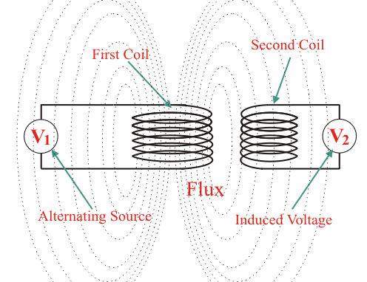

*Mutual induction between two current carrying coils*

In HATIA-1(132/33KV) Substation , it has four 50MVA transformers which converts 132KV to 33KV

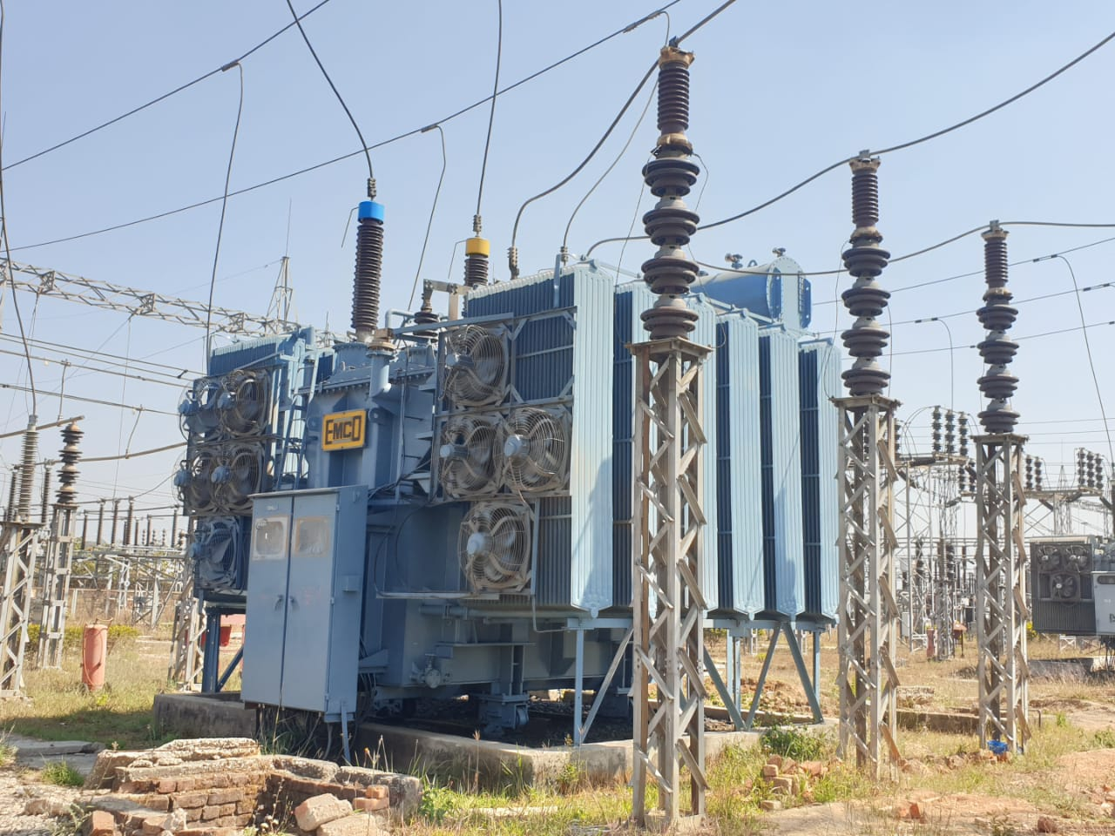

*50 MVA transformer in HATIA-1*

In HATIA-2(220/132KV) Substation , it has three 150MVA transformers which converts 220KV to 132KV

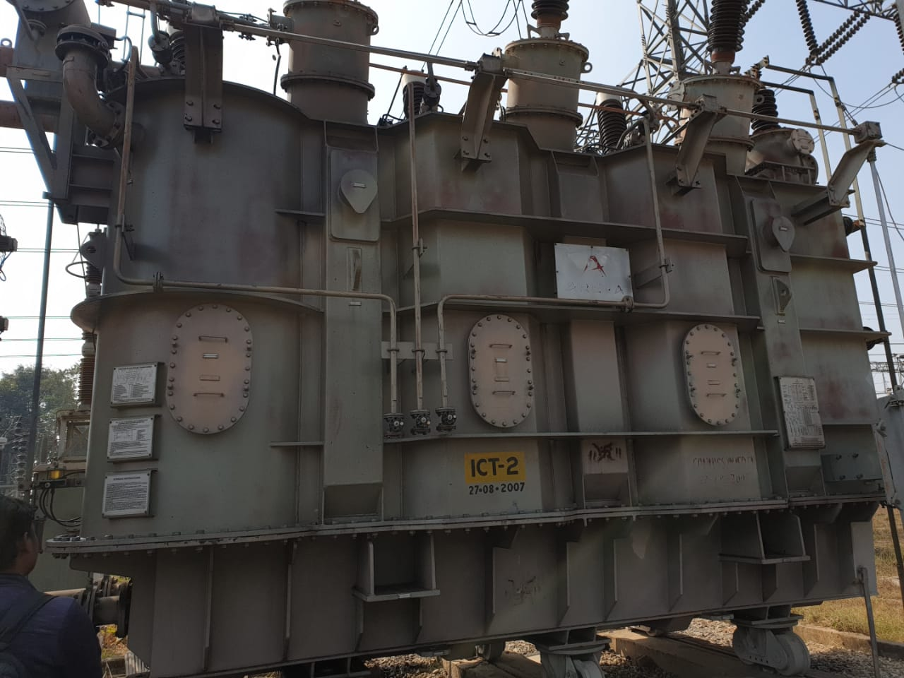

*150 MVA transformer in HATIA-2*

Types of Transformer

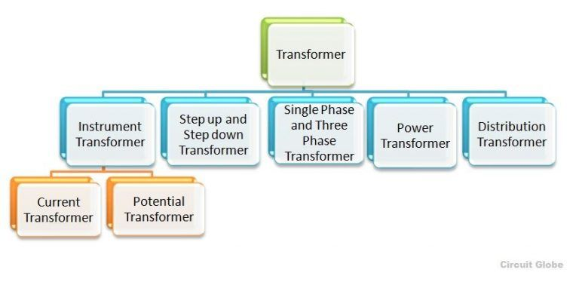There are various **types of transformer** used in the electrical power system for different purposes, like generation, distribution and transmission and utilization of electrical power

[Parts Of A Transformer](https://www.miracle.net.in/blog/parts-of-a-transformer/)

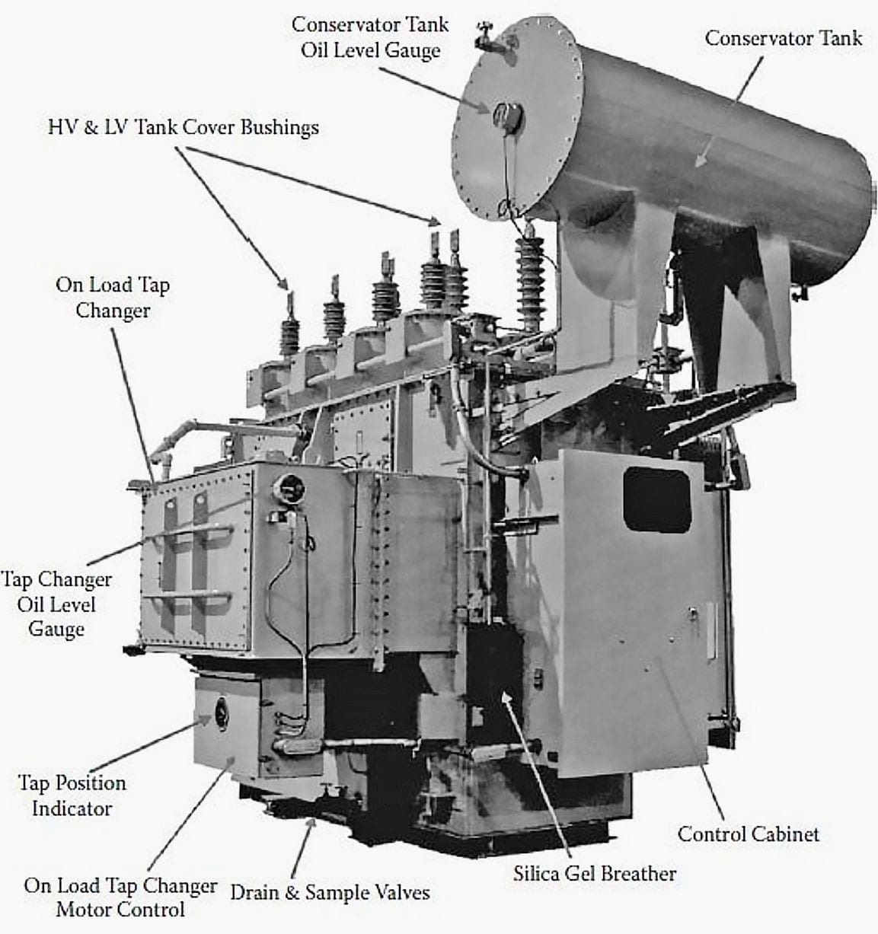

#### *Core*

The core of the transformer is used to support the windings. It is made of soft iron to reduce eddy current loss and Hysteresis loss, and provides low reluctance path to the flow of magnetic flux. The diameter of a transformer’s core is directly proportional to copper loss and inversely proportional to iron loss.

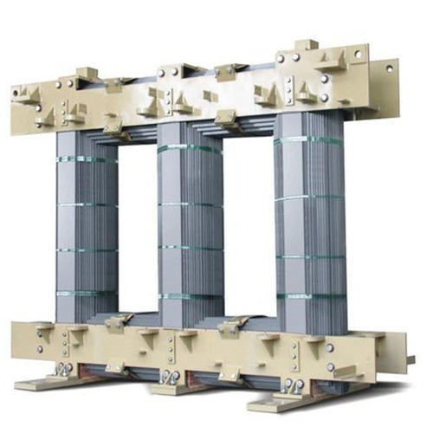

#### *Windings*

Windings consist of several copper coil turns bundled together, each bundle connected to form a complete winding. Windings can be based either on the input-output supply or on the voltage range. Windings that are based on supply are classified into primary and secondary windings, meaning the windings to which the input and output voltage is applied respectively. On the other hand, windings based on voltage range can be classified into high voltage and low voltage windings.

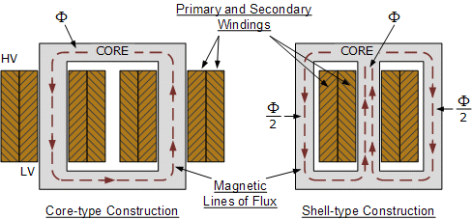

#### *Insulating materials*

Insulating materials like papers and card boards are used to isolate primary and secondary windings from each other as well as the transformer core. These windings are made of copper due to high conductivity and ductility. High conductivity minimizes the amount of copper needed and minimizes losses. Moreover, high ductility results in easy bending of conductors into tight winding around the core that also minimizes the amount of copper and volume of winding.

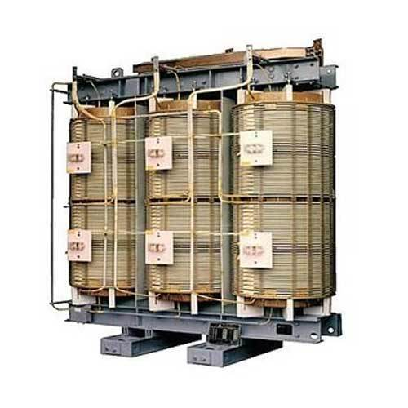

#### *Transformer oil*

#### The transformer oil insulates as well as cools the core and coil assembly. The core and windings of the transformer must be completely immersed in the oil that normally contains hydrocarbon mineral oils.

#### Conservator

The conservator is an airtight metallic cylindrical drum fitted above the transformer that conserves the transformer oil. It is vented at the top and is filled only half with the oil to allow expansion and contraction during temperature variations. However the main tank of the transformer with which the conservator is connected is completely filled with the oil through a pipeline.

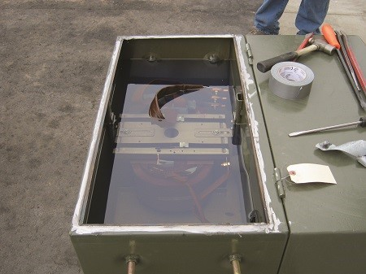

#### *Breather*

The breather is a cylindrical container filled with silica gel, which is used to keep the air that enters the tank moisture-free. This is because the insulating oil when reacts with moisture can affect the insulation and cause internal faults, which is why it is a must to keep the air free from moisture. In the breather, when the air passes through the silica gel, the moisture contents are absorbed by the silica crystals.

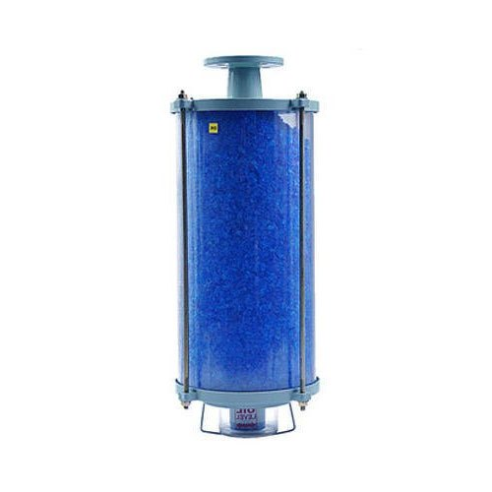

#### *Tap changer*

To balance voltage variations within the transformer, tap changers are used. There are two types of tap changers – on load and off load. In on load tap changers, tapping can be changed without isolating transformer from the supply, while in off load, the transformer needs to be disconnected from the supply.

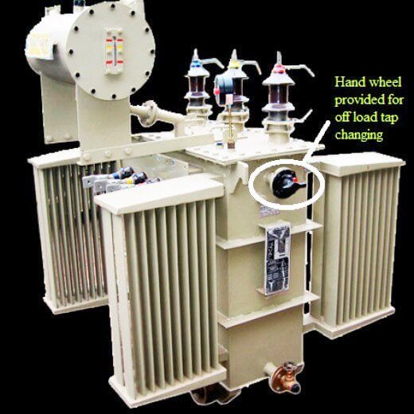

#### *Cooling tubes*

As the name suggests, cooling tubes are used to cool the transformer oil. The circulation of oil within the transformer may be natural or forced. In the case of natural circulation, when the oil temperature rises, the hot oil naturally moves to the top and cold oil moves down, while in case of forced circulation, an eternal pump is used.

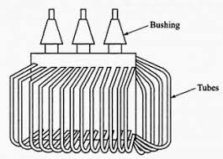

Placed over the connecting pipe that runs from the main tank to conservator tank the Buchholz Relay senses the faults occurring within the transformer. It operates by the gases emitted due to decomposition of transformer oil during internal faults. Thus, this device is used to sense and in turn protect the transformer from internal faults.

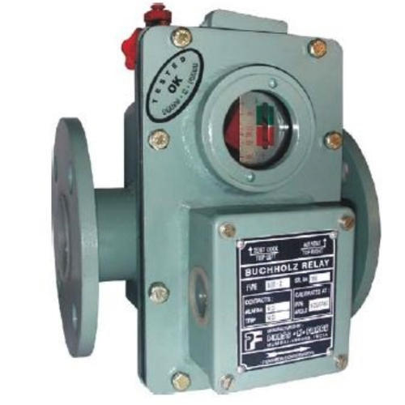

#### *Explosion vent*

The boiling hot oil from the transformer is expelled during internal faults through the explosion vent to avoid explosion of the transformer. This is generally placed above the level of the conservatory tank.

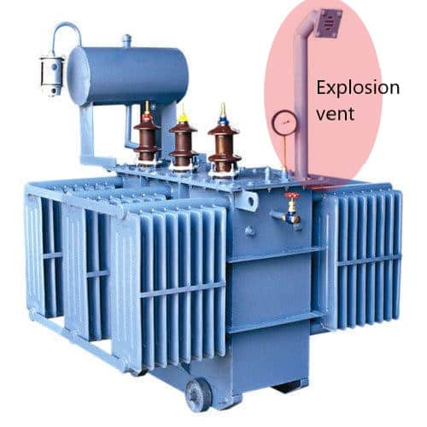

#### *Conservator Tank*

Its a cylindrical tank mounted on supporting structure on the roof the transformer main tank. The main function of *conservator tank of transformer* is to provide adequate space for expansion of oil inside the transformer.

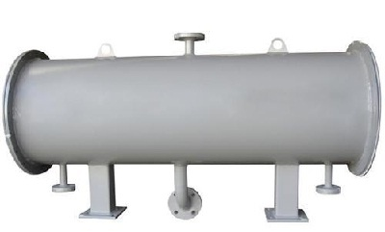

**3.Ciruit Breaker**

**Circuit breakers** are used to open and close circuits. They can be operated manually to perform maintenance or will automatically trip if a short circuit occurs. This function in the power system is similar to that of the fuses or breakers in a household distribution panel.

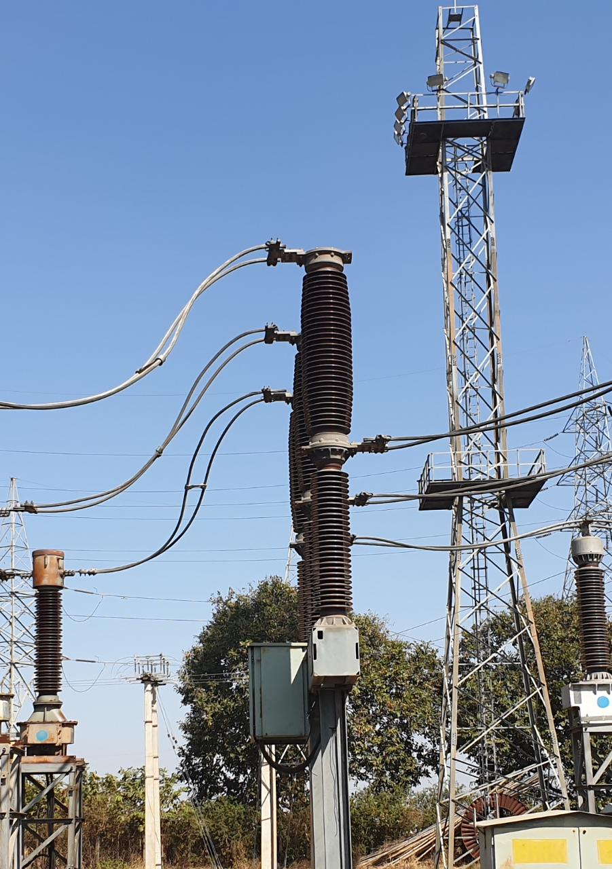A [circuit breaker](https://circuitglobe.com/circuit-breaker.html) in which SF6 under pressure gas is used to extinguish the arc is called SF6 circuit breaker. SF6 (sulphur hexafluoride) gas has excellent dielectric, arc quenching, chemical and other physical properties which have proved its superiority over other arc quenching mediums such as oil or air.

**4.Current Transformer (CT)**

The **Current Transformer** ( C.T. ), is a type of “instrument transformer” that is designed to produce an alternating current in its secondary winding which is proportional to the current being measured in its primary. *Current transformers* reduce high voltage currents to a much lower value and provide a convenient way of safely monitoring the actual electrical current flowing in an AC transmission line using a standard ammeter. The principal of operation of a basic current transformer is slightly different from that of an ordinary voltage transformer.

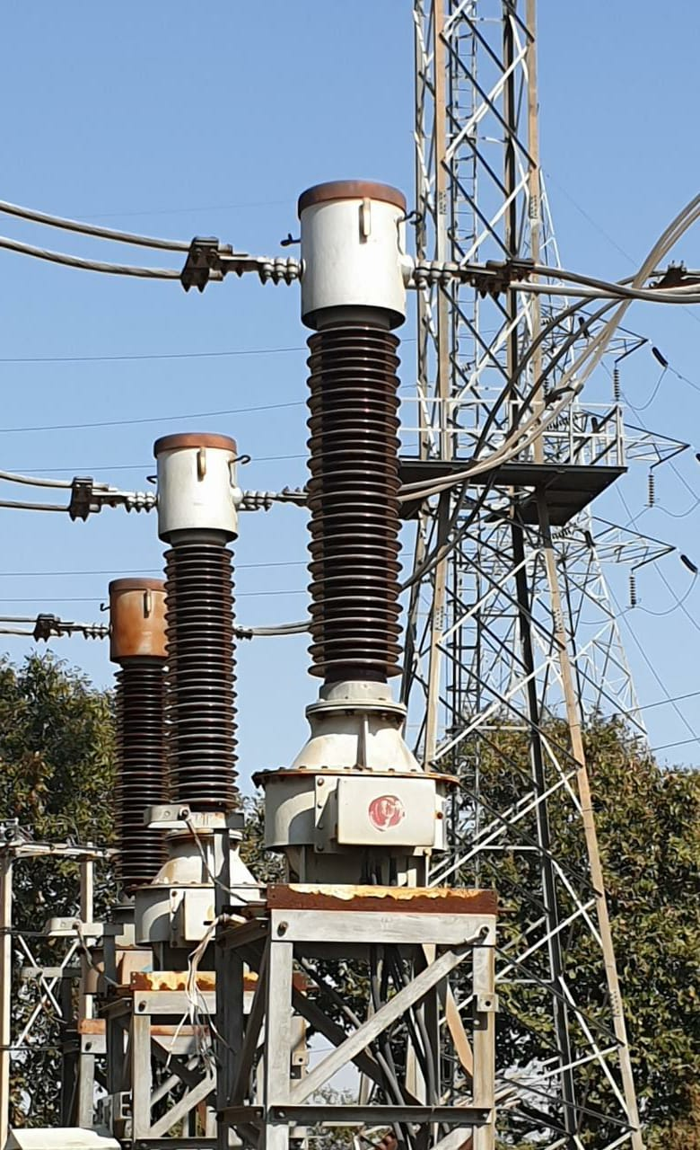

**5.Isolators**

The isolator is one [type of switching device](https://www.elprocus.com/mosfet-as-a-switch-circuit-diagram-free-circuits/), and the main function of this is to make sure that a circuit is totally not triggered in order to perform the preservation. These are also recognizable like isolation switches to isolate the circuits. These switches are applicable in industrial, distribution of electrical power, etc. High voltage type isolation switches are utilized in substations for permitting isolation of equipment like transformers, circuit breakers.

Usually, the disconnector switch is not proposed for circuit control but it is for isolation. Isolators are activated either automatically or manually.

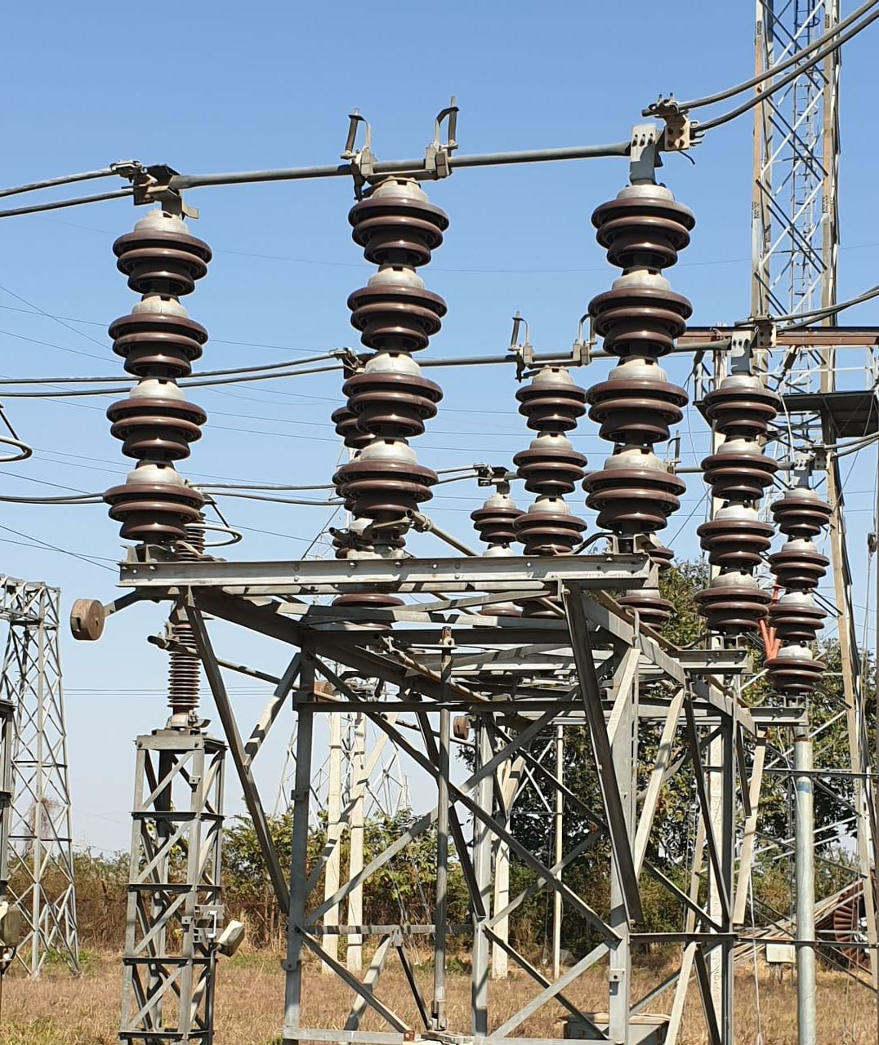

**6. Potential (Voltage) Transformer (PT)**

The potential transformer may be defined as an instrument transformer used for the transformation of voltage from a higher value to the lower value. This transformer step down the voltage to a safe limit value which can be easily measured by the ordinary low voltage instrument like a voltmeter, wattmeter and watt-hour meters, etc.

The secondary voltage of the PT is generally 110 V. In an ideal **potential transformer** or **voltage transformer**, when rated burden gets connected across the secondary; the ratio of primary and secondary voltages of transformer is equal to the [turns ratio](https://www.electrical4u.com/emf-equation-of-transformer-turns-voltage-transformation-ratio-of-transformer/) and furthermore, the two terminal voltages are in precise phase opposite to each other.

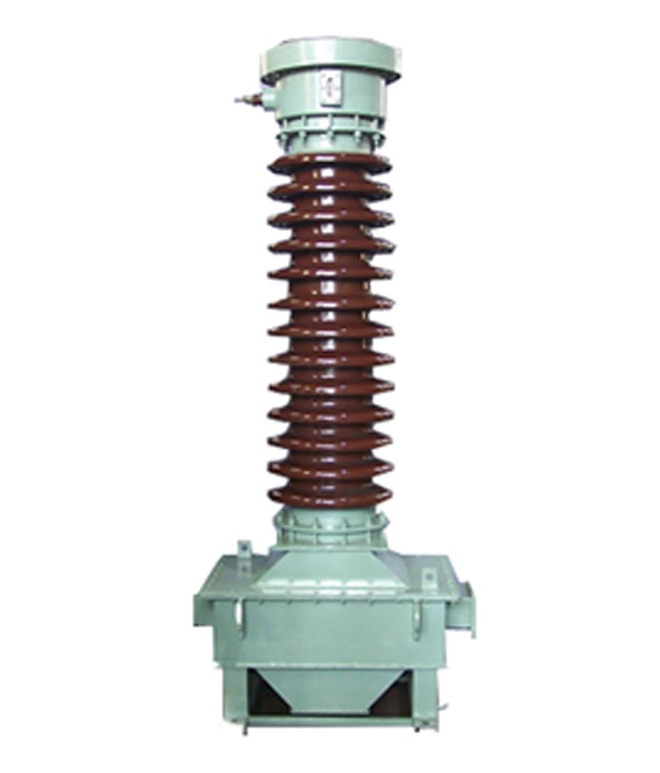

**7.Capacitive Voltage Transformers (CVT)**

The capacitive voltage [transformer](https://circuitglobe.com/what-is-a-transformer.html) step-down the high voltage input signals and provide the low voltage signals which can easily measure through the measuring instrument. The Capacitive voltage transformer (CVT) is also called capacitive [potential transformer](https://circuitglobe.com/potential-transformer-pt.html)

For measuring high voltage (above 100kV) the high insulated transformer is required. **The highly insulated transformer is quite expensive as compared to the normal transformer.** For reducing the cost, the capacitive potential transformer is used in the system. The CVT  is cheap, and their performance is not much inferior to the highly insulated transformer.

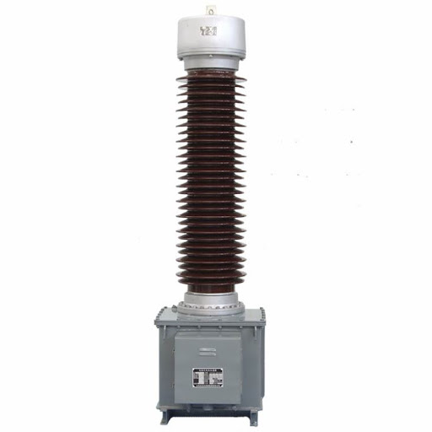

**8.Lightening Arrester (LA)**

The device which is used for the protection of the equipment at the substations against travelling waves, such type of device is called lightning arrester or surge diverter. In other words, lightning arrester diverts the abnormals high voltage to the ground without affecting the continuity of supply. It is connected between the line and earth, i.e., in parallel with the equipment to be protected at the substation.

The arrestor provides a conducting path to the waves of relatively low impedance between the line and the ground. The surge impedance of the line restricts the amplitude of current flowing to ground.

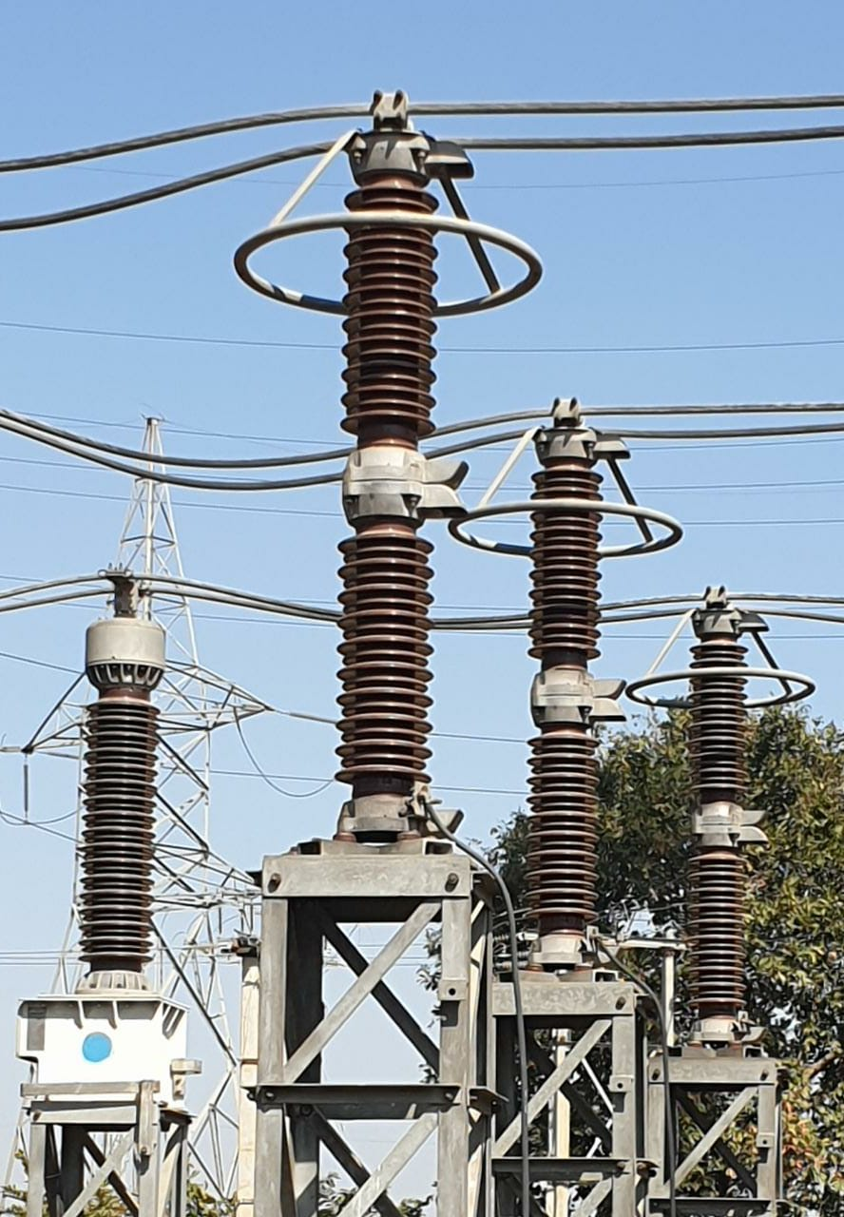

**9.Wave Trap (WT)**

The wave trap is a cylindrical-shaped device mounted on the transmission line to prevent the transmission of high-frequency (30kHz to 200 kHz) on the power line or transmission line to the electrical equipment such as the main bus, transformer.

The wave trap blocks the high frequency, so we can tell wave trap as a low pass filter or band block filter.

The substation over 66kv uses a wave trap to filter "carrier communication frequency".   
We can use a line trap or wave trap along with the electrical equipment [CVT (Capacitive voltage transformer).](https://circuitglobe.com/capacitive-voltage-transformer-cvt.html)

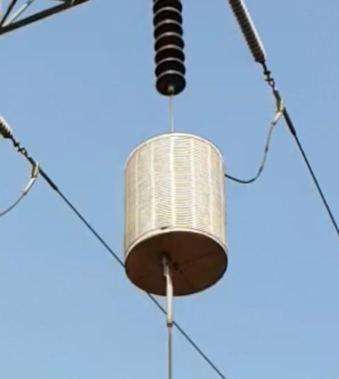

**10.Insulators**

An insulator gives support to the overhead line conductors on the poles to prevent the current flow toward earth. In the [transmission lines](https://www.elprocus.com/transmission-lines-types-equation-and-applications/), it plays an essential role in its operation. The designing of an insulator can be done using different materials like rubber, wood, plastic, mica, etc. The special materials used in the electrical system are glass, ceramic, PVC, steatite, polymer, etc. But the most common material used in the insulator is porcelain and also special composition, steatite, glass materials are also used.

These are used in transmission & distribution system where each insulator consists of several insulating discs. If one disc used 11kv voltage then the remaining discs use 66kv voltage.

These are classified into different types based on their rating which includes the following

1.Pin Insulator

2.Suspension Insulator

3.Strain Insulator

4.Shackle Insulator

5.Post-Insulator

6.Stay Insulator

7.Disc Insulator

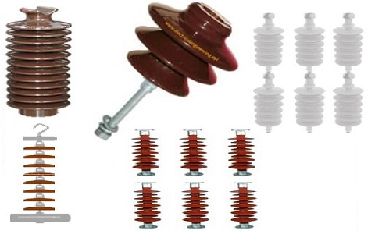

**11.Relays**

A relay is automatic device which senses an abnormal condition of [electrical circuit](https://www.electrical4u.com/electric-circuit-or-electrical-network/) and closes its contacts. These contacts in turns close and complete the [circuit breaker](https://www.electrical4u.com/electrical-circuit-breaker-operation-and-types-of-circuit-breaker/) trip coil circuit hence make the circuit breaker tripped for disconnecting the faulty portion of the electrical circuit from rest of the healthy circuit.

Types of protection relays are mainly based on their characteristic, logic, on actuating parameter and operation mechanism.

Based on operation mechanism protection relay can be categorized as [electromagnetic relay](https://www.electrical4u.com/electromagnetic-relay-working-types-of-electromagnetic-relays/), static relay and mechanical relay.

Based on Characteristic the protection relay can be categorized as:

1. Definite time relays
2. Inverse time relays with definite minimum time(IDMT)
3. Instantaneous relays.
4. IDMT with inst.
5. Stepped characteristic.
6. Programmed switches.
7. Voltage restraint over current relay.

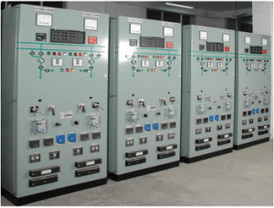

**12.Bus Bar**

An electrical bus bar is defined as a conductor or a group of conductor used for collecting electric power from the incoming feeders and distributes them to the outgoing feeders. In other words, it is a type of electrical junction in which all the incoming and outgoing electrical current meets. Thus, the electrical bus bar collects the electric power at one location.

The bus bar system consists the isolator and the circuit breaker. On the occurrence of a fault, the circuit breaker is tripped off and the faulty section of the busbar is easily disconnected from the circuit.

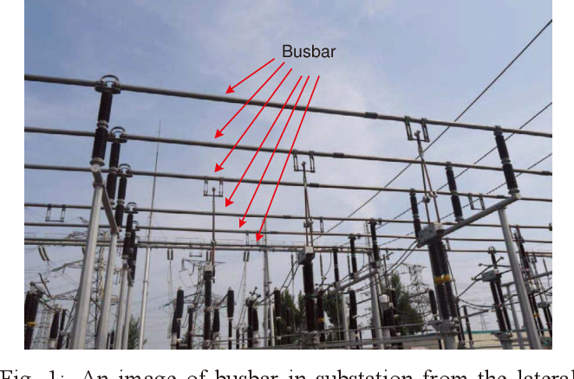The electrical bus bar is available in rectangular, cross-sectional, round and many other shapes. The rectangular bus bar is mostly used in the power system. The copper and aluminium are used for the manufacturing of the electrical bus bar.

**13. Bus Coupler**

Bus coupler is a device which is used to couple one [bus](https://en.wikipedia.org/wiki/Busbar) to the other without any interruption in [power supply](https://en.wikipedia.org/wiki/Power_supply) and without creating hazardous arcs. Bus coupler is a breaker used to couple two busbars in order to perform maintenance on other circuit breakers associated with that busbar.

It is achieved with the help of a [circuit breaker](https://en.wikipedia.org/wiki/Circuit_breaker) and [isolators](https://en.wikipedia.org/wiki/Isolator_switch).

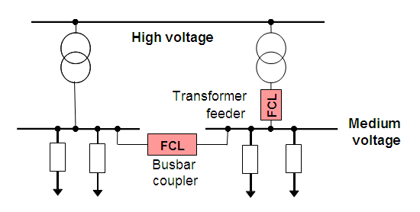

**14. DC System**

The term DC is used to refer to power systems that use only one polarity of voltage or current, and to refer to the constant, zero-frequency, or slowly varying local mean value of a voltage or current.

Power substation can have one or several DC systems. Factors affecting the number of systems are **the need of more than one voltage level** and the need of **duplicating systems**.

The DC system is the most important component of a high voltage industrial/utility substation. It supplies the energy needed to manage the protective devices and high voltage components and allows electrical faults to be safely isolated. Most high voltage substations house either a sealed or flooded cell battery bank.

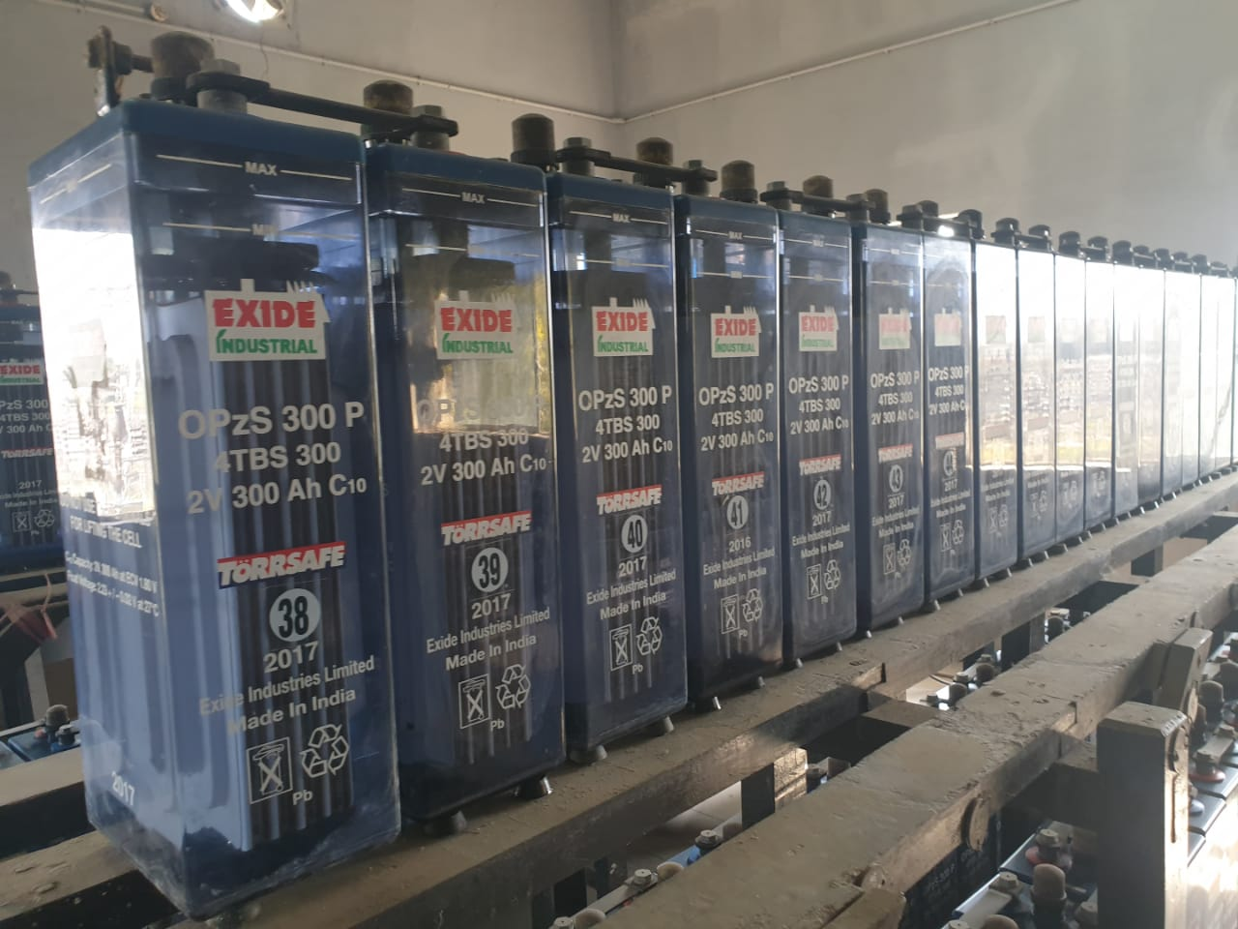

**15.PLCC**

Power-line communication carrier (also known as power-line carrier or PLCC) carries data on a conductor that is also used simultaneously for AC [electric power transmission](https://en.wikipedia.org/wiki/Electric_power_transmission) or [electric power distribution](https://en.wikipedia.org/wiki/Electric_power_distribution) to consumers. Wave trap is used for this purpose.

A wide range of power-line communication technologies are needed for different applications, ranging from [home automation](https://en.wikipedia.org/wiki/Home_automation) to [Internet access](https://en.wikipedia.org/wiki/Internet_access) which is often called [broadband over power lines](https://en.wikipedia.org/wiki/Broadband_over_power_lines) (BPL). Most PLC technologies limit themselves to one type of wires (such as premises wiring within a single building), but some can cross between two levels (for example, both the distribution network and premises wiring). Typically transformers prevent propagating the signal, which requires multiple technologies to form very large networks. Various data rates and frequencies are used in different situations.

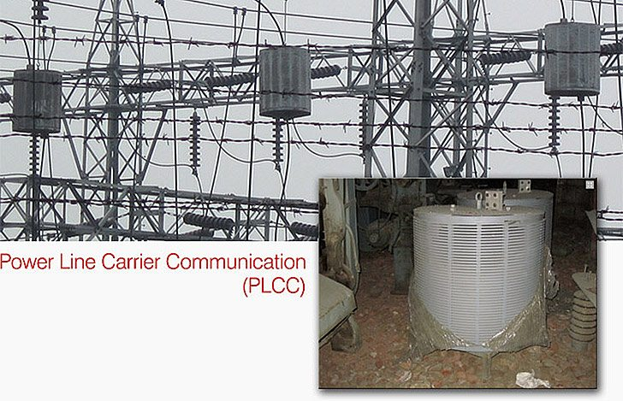

**16. Control System**

The control system in a substation is a vital part that supervises, protects and controls the transmission of electrical power. The increasing complexity in the substations of today, together with the increasing transmitted power and the increasing fault current levels, means increasing requirement set on the control and protection equipment.

Dependent of the stations location in the networks and the power consumption, the operation and maintenance organization of the customer and government regulations etc., many choices must be done in order to achieve lowest possible Life Cycle Cost (LCC). The highest possible service reliability is a general goal. Flexibility and maintainability are also important factors in order to attain a total reliability.

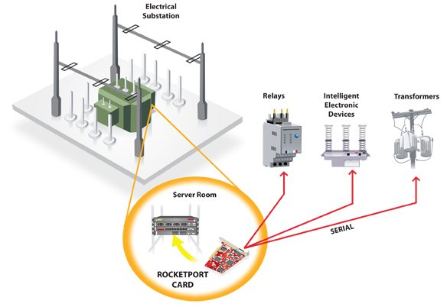

**17. Substation & Equipment Earthing**

We connect all the points to be earthed with the earthing grid with corrosion resistance mild still rods. We bury the connection rods a minimum 600 mm below the ground level. If these horizontally buried rods cross a cable trench, road, underground pipework, or rail track the rods should cross the barriers through at least 300 mm below the bottom of the barriers.

The points we must earth in an [electrical substation](https://www.electrical4u.com/electrical-power-substation-engineering-and-layout/) include:

1. The neutral point of different [voltage](https://www.electrical4u.com/voltage-or-electric-potential-difference/) levels
2. The metallic enclosure of all [current](https://www.electrical4u.com/electric-current-and-theory-of-electricity/) carrying equipment
3. The framework of all current carrying equipment
4. All the metallic structure even not associated with current carrying equipment

#### *Earthing of Gantry Tower*

The shield wire comes down along the a leg of gantry structure. The shield wire which comes down along the a leg of gantry structure is referred as down comer. The downcomer is clamped with the leg members of the structure at every 2 meters intervals. This downcomer is connected with a earthing lead coming directly from a pipe earth electrode. Diagonally opposite leg of the same structure should directly be connected to the main earthing grid via riser.

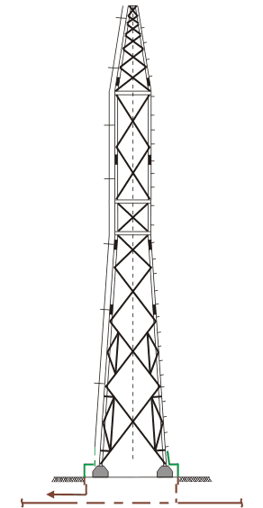

## **Earthing of Bus Post Insulator**

Each bus post insulator or BPI is connected to the main earthing grid via two risers. A 50 mm × 10 mm ms flat comes down along the BPI support structure from each of the two earthing points of BPI metallic base. These ms flats from base of the BPI are connected to the risers come from x and y [conductor](https://www.electrical4u.com/electrical-conductor/) of main earthing grid.

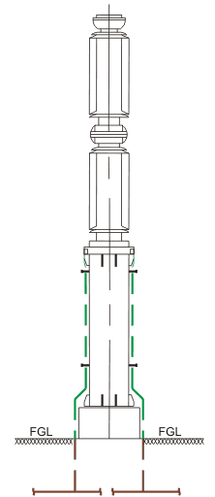

## *Earthing of Current Transformer*

One 50 mm × 10 mm ms flat comes down along the a leg of [current transformer](https://www.electrical4u.com/current-transformer-ct-class-ratio-error-phase-angle-error-in-current-transformer/) support structure from metallic base of the CT. This is connected to the main earthing grid via riser. Diagonally opposite vertical leg members of the structure is connected to the main earthing grid via another riser. If first riser comes from x [conductor](https://www.electrical4u.com/electrical-conductor/) of the ground grid then second riser must come from the rod conductor of y direction.

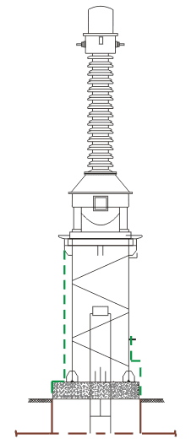The CT junction box should also be connected to the main earthing grid from two points by means of 50 mm × 10 mm ms flats.

## *Earthing of Circuit Breaker*

Supporting structure of each pole of a [circuit breaker](https://www.electrical4u.com/electrical-circuit-breaker-operation-and-types-of-circuit-breaker/) along with the metallic base of the poles are connected to the main earthing grid via two risers one preferably from x and other from y direction. The structure of the poles are connected together with 50 mm × 8 mm ms flat. The mechanism box of each pole is also connected to the main earthing grid via 50 mm × 10 mm ms flat.

## *Earthing of Isolator*

The base of each pole of the isolator should be connected together with the help of one 50 mm × 10 mm ms flat. This ms flat will be connected to the main earthing grid via two risers one preferably from x and other from y direction earth mat conductors. The mechanism box of the isolator should be connected to the auxiliary earth mat and the auxiliary earth mat then connected to the main earthing grid to two different points on the main earthing grid.

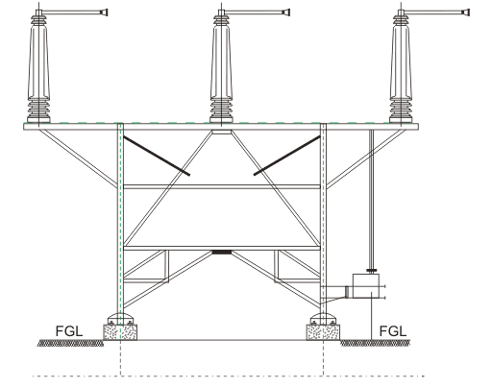

## *Earthing of Lightning Arrestors*

The base of the lightning arrestors must be connected to the main earthing grid via one riser and structure of the lightning arrestors must be connected to the main earthing grid via another riser. One extra earthing connection is provided in lightning arrestors which connects a treated earth pit via surge counter of the arrestors. This earth pit may be with test link.

## *Earthing of Capacitive Voltage Transformer*

The base of the CVT or capacitive voltage transformer is connected to the main earthing grid via a riser. The special earthing point on the base of the CVT is connected to the pipe earth electrode with 50 mm × 8 mm ms flat. The bottom portion of the support structure is also connected to the main earthing grid via riser. Two opposite earthing points of the CVT junction box should also be connected to the main earthing grid.

## *Earthing of Cable Sealing System*

The supporting structure of a cable sealing system should be connected to the main earthing grid via two risers. The earthing strip of size 50 mm × 10 mm ms flat must come down from the top of the supporting structure.

**Conclusion**

Now from this report we can conclude that electricity plays an important role in our life. We are made aware of how the transmission the transmission of electricity is done. We too came to know about the various parts of the substation system. The three wings of electrical system viz. generation, transmission and distribution are connected to each other and that too very perfectly.

JUSNL GSS HATIA-I and II provided us with great learning opportunities and sharpening our gained knowledge.

Thus for effective transmission and distribution a substation must:

• Ensure steady state and transient stability

• Effective voltage control

• Prevention of loss of synchronism

• Establishment of economic load distribution